

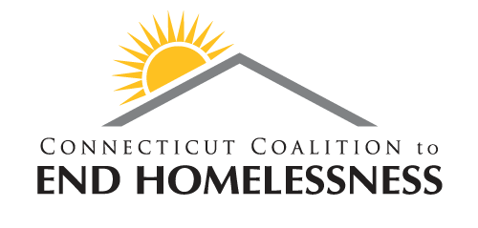



Continuing Notice of Nondiscrimination

Naugatuck Valley Community College does not discriminate on the basis of race, color, religious creed, age, sex, national origin, marital status, ancestry, present or past history of mental disorder, learning disability or physical disability, sexual orientation, gender identity and expression or genetic information in its programs and activities.  In addition, the College does not discriminate in employment on the additional basis of veteran status or criminal record. The following individual has been designated to handle nondiscrimination policies regarding disability policies:  Robert Divjak, Director of Facilities/Section 504/ADA Coordinator, Room C216, Naugatuck Valley Community College, 750 Chase Parkway, Waterbury, CT 06708; 203-575-8235.   The following individual has been designated to handle nondiscrimination policies regarding sex discrimination as well as other forms of prohibited discrimination:  Jacquie Swanson, Associate Director of Human Resources/Title IX Coordinator, Room K704, Naugatuck Valley Community College, 750 Chase Parkway, Waterbury, CT 06708; 203-575-8043. ocm

**Sponsored by: The Waterbury Ten Year Plan to End Homelessness**

**and Connecticut Coalition to End Homelessness**

**Are You Age 13-24?**

**Would You Like to Participate in a Housing Survey?**

**Receive a Gift Card for Your Participation!**

**Date: Wednesday, 01/24**

**Location: Kinney Hall 5th Floor Walkway**

**Time:10:30 a.m. – 1:00 p.m.**

**____________________________________**

**Date: Tuesday, 01/30**

**Location: Founder’s Hall Entryway**

**Time: 9:00 a.m. – Noon**

**_____________________________________**

**Date: Tuesday, 01/30**

**Location: Prism Lounge**

**Time: Noon – 2:30 p.m.**

K. LeBlanc